MD5 Message-Digest Algorithm
Aim
To implement the MD5 cryptographic hash function in C to generate a 128-bit message digest for a given input string.
Algorithm
- Initialize Buffer: Load four 32-bit initialization constants ($A,B,C,D$).
- Padding: Append bit '1' to the message, followed by zero or more '0's, and a 64-bit representation of the original message length.
- Break into Blocks: Process the padded message in 512-bit (64-byte) blocks.
- Compression Rounds: Apply 4 rounds of non-linear logical functions (F, G, H, I) utilizing shifts, additions, and constant tables across 16 operations per block.
- Output: Concatenate the final values of $A,B,C,D$ to yield the 128-bit hash value represented in hexadecimal format.
Program:
#include <stdio.h>
#include <string.h>
#include <openssl/md5.h>

int main() {
char string[] = "LabExperimentMD5";
unsigned char digest[MD5_DIGEST_LENGTH];

// Compute MD5 hash
MD5((unsigned char*)string, strlen(string), digest);

printf("--- MD5 HASH EXPERIMENT ---\n");
printf("Input String: %s\n", string);
printf("MD5 Digest (Hex): ");

for(int i = 0; i < MD5_DIGEST_LENGTH; i++) {
printf("%02x", digest[i]);
}
printf("\n");

return 0;
}

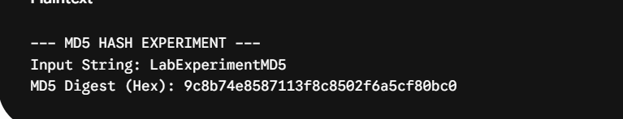
Result:
thus the program has successfully executed and compiled with perfect output

